PRACTICE TASK CLASS -3
- set the number for lines in vi editor
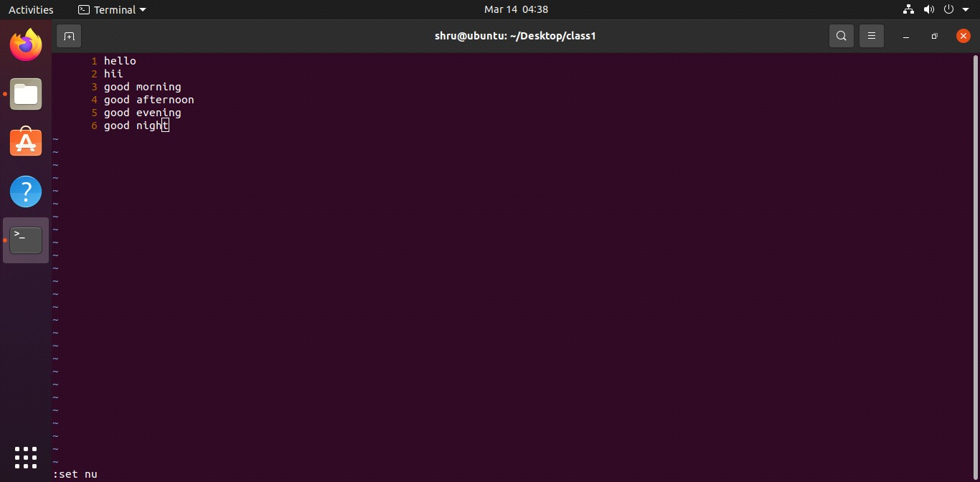
- remove the number for lines in vi editor
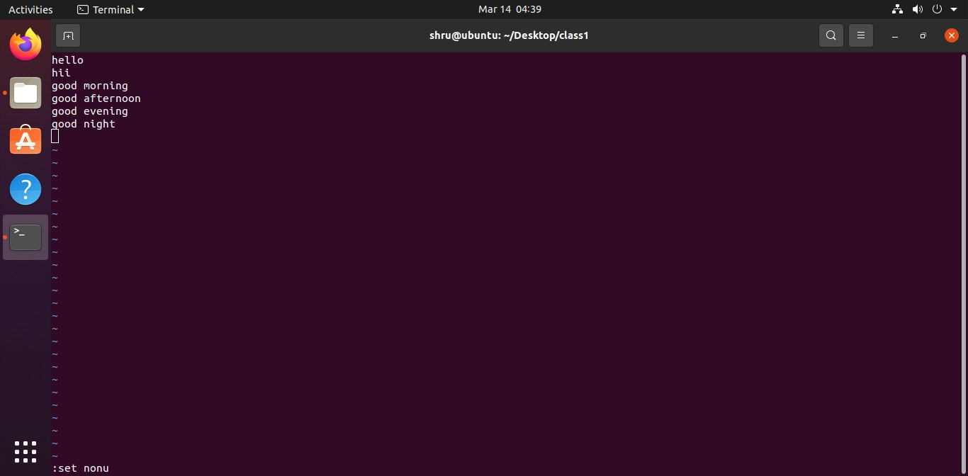
- search and replace pattern for 3 lines

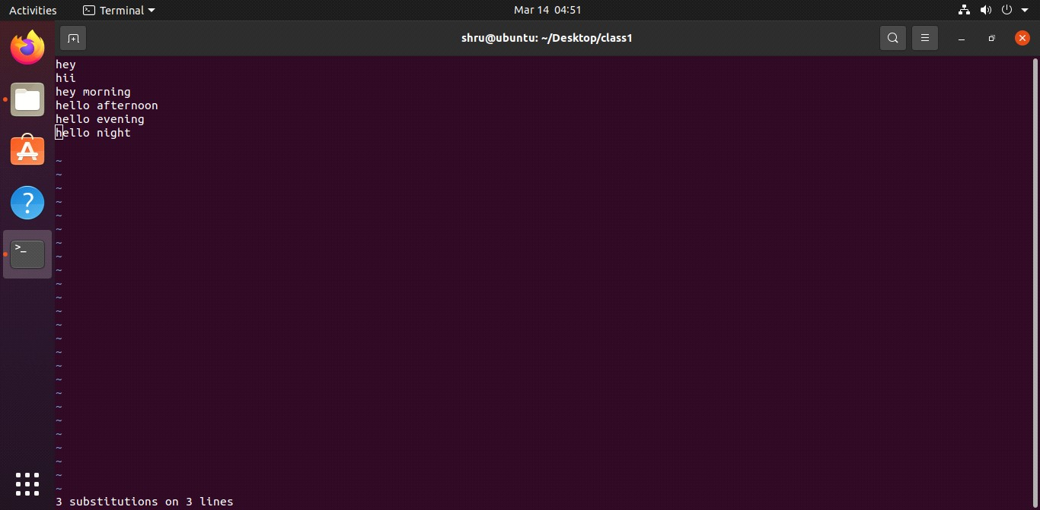

- search and replace pattern in particular line
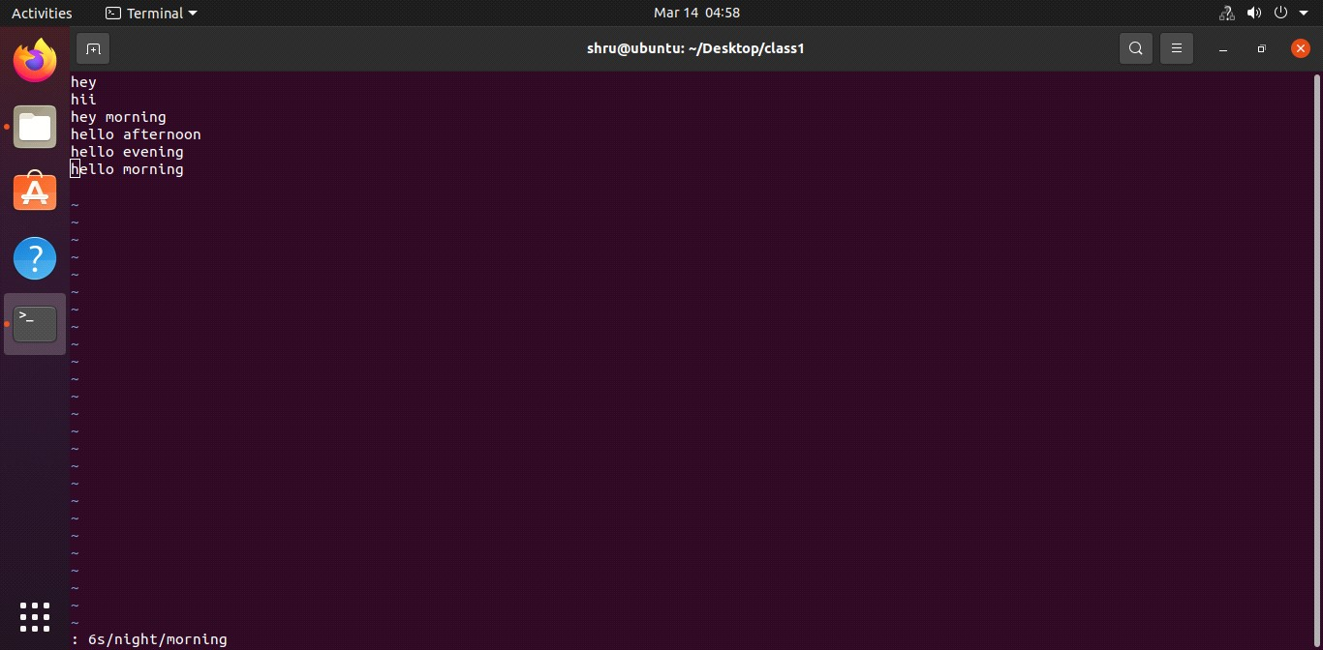
- save the content and exit from vi editor

